Job tracker
So we are creating this job tracker extension
A chrome extension that :
- Detects when youre on a job listing page(linkdln, indeed)
- Lets you save the job in one click
- Shows a dashboard with all your applications, their status, and reminders.

Project Structure:
job-tracker/
├── manifest.json
├── background.js
├── content.js
├── popup/
│ ├── popup.html
│ └── popup.js
├── dashboard/
│ ├── dashboard.html
│ └── dashboard.js
└── icons/

Step 1 – creating manifest.json file with the code
What each part means :-
manifest_version: 3 — latest version Chrome requires, always use this
permissions — we're asking Chrome to allow storage, alarms, notifications etc.
action — defines the popup that opens when you click the extension icon
background — a script that runs silently in the background always
content_scripts — scripts that run ON a webpage, only on LinkedIn/Indeed URLs

The icons part will do later.

Now loaded it in chrome
Steps :
- Open chrome and go to chrome://extensions
- Turn on the developer mode
- Click load unpacked
- Select your folder
- You should see your extension appear in the list.
Now lets head towards the popup UI
┌─────────────────────────┐
│ 💼 Job Tracker │
│─────────────────────────│
│ Job Title │
│ [____________________] │
│ │
│ Company │
│ [____________________] │
│ │
│ Status │
│ [Applied ▾] │
│ │
│ [Save Job] [Dashboard] │

The above one is the idea
Now made popup.html
Then popup.js
This is what popup.js do :-
Chrome.storage.local.get – reads whatever is already saved.
existingJobs.push(newjob) – saves the updated list back.
Date.now() – gives every job a unique ID using timestamp.
Dashboard button opens dashboard.html as a new tab.

Now we made dashboard.html
And then dashboard.js
And that’s how we set up the core of the entire app
What ive buid so far : -
- Chrome extension loading properly
- Popup ui with inputs
- Saving jobs to chrome storage
- Dahshboard with live stats
- Status update dropdown
- Delete functionality
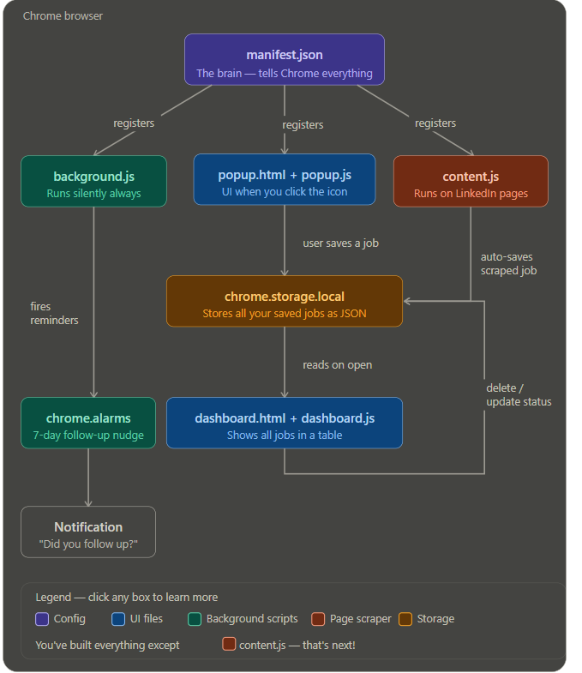
manifest.json is the entry point — Chrome reads it first and uses it to register all 3 other scripts. After that everything runs independently.
popup.js handles user input — when you type a job and hit save, it writes to chrome.storage.local. That storage is basically a mini database living inside Chrome. When you click Dashboard, dashboard.js reads from that same storage and renders the table.
background.js runs silently in the background 24/7 — even when you're not using the extension. It's in charge of setting timers via chrome.alarms and firing notifications.
content.js is the piece we haven't built yet — it's the script that runs on LinkedIn's page itself, reads the job title and company from the DOM, and auto-fills your popup so you don't have to type anything manually.
The loop on the right side of the diagram shows dashboard.js writing back to storage when you change a status or delete a job.

First lets understand the flow ----
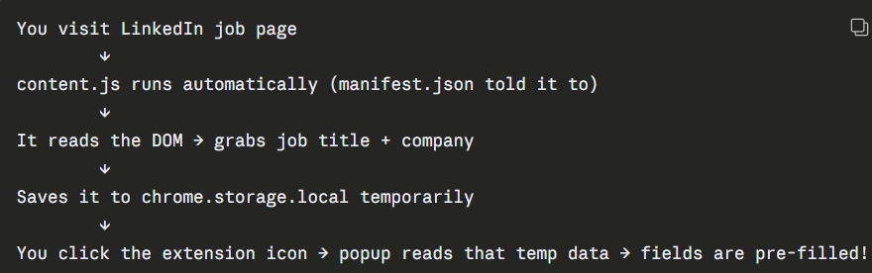

Then we created content.js
And popup.js
and we are getting error the extension not working on linkdin
we made some changes in the content.js and now its working

problems to fix :
it is only working in linkdln
also when I click on any job in linkdln and then the extension I see the fields filled but when I click on another job and then click on the extension the field is empty and ii have to reload the page again and then open the extension again to see it in fields
another issue is the job I saved I can see it in dashboard but the delete icon does not work
also I tried the extension in indeed but it is not working
Fix Bug 1 — Watch for URL changes in content.js:
What changed and why — important to understand:
MutationObserver is a browser API that watches the DOM for any changes. When LinkedIn swaps in a new job's content, the DOM changes, which triggers our observer. We then check if the URL changed — if yes, we re-scrape after a short delay.
Bug solved. Now when I open different jobs and then click on job tracker the fields are prefilled ,
Now another issue comes that is first time I opened linkdln I have to refresh it again to scrape the data
For Bug 2 — Indeed support,

It is working now in both linkdln and indeed
Till now this is what we implemented.
✅ Done:
- Auto-scraping from LinkedIn
- Save / delete / status update
- Dashboard with stats
- Export CSV
- Clean matching theme
- CSP errors fixed

What we need to add is :
The follow up reminders about jobs
Different tab for different apps like linkdln and Naukri so that I will remember exactly on which platform I applied this job for
The logo
Color-coded status badges
Stats page — "You applied to 34 jobs this month"
Follow-up reminder toggle

